**Topic:** Fungus from Acrylic Nails in 2022 – Vigoursoul

**Focus keyword:** Fungus from Acrylic Nails

**Meta Title:** Fungus from Acrylic Nails in 2022 – Vigoursoul

**Meta Description:** Fungus from Acrylic Nails infections are a typical artificial nail problem. They are mainly caused by moisture trapped beneath your nails.

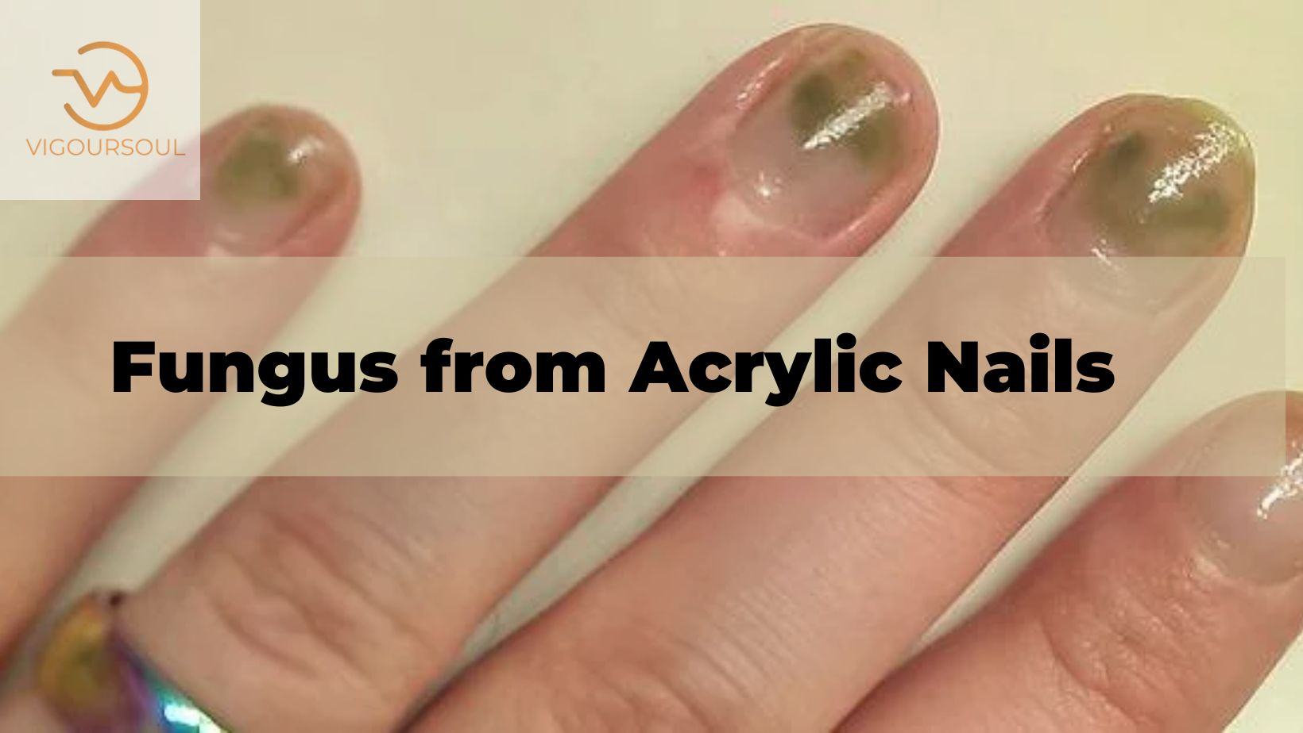

Acrylic nail complications include fungal infections. They are mainly caused by moisture trapped beneath your nails, which promotes fungal development. Most fungal infections are minor and treatable at home. Prescription antifungal medicine frequently cures more severe illnesses. Acrylic nail complications include fungal infections. They are mainly caused by moisture trapped beneath your nails, which promotes fungal development. Most fungal infections are minor and treatable at home. Prescription antifungal medicine frequently cures more severe illnesses.

**Table of content:**

**First Stage Early Stage Fingernails Fungus from Acrylic Nails:**

A cracked or thickened nail a foul odor emanating from the nail Pain and discomfort, particularly when applying pressure on your nail a discoloration that is yellow, green, black, or white.

**Green Fingernail Fungus from a nails:**

Acrylic nail complications include fungal infections. They are mainly caused by moisture trapped beneath your nails, which promotes fungal development. Most fungal infections are minor and treatable at home. Prescription antifungal drugs frequently clean up more severe infections.

**Fungal Infection Fingernail Fungus from Acrylic Nails:**

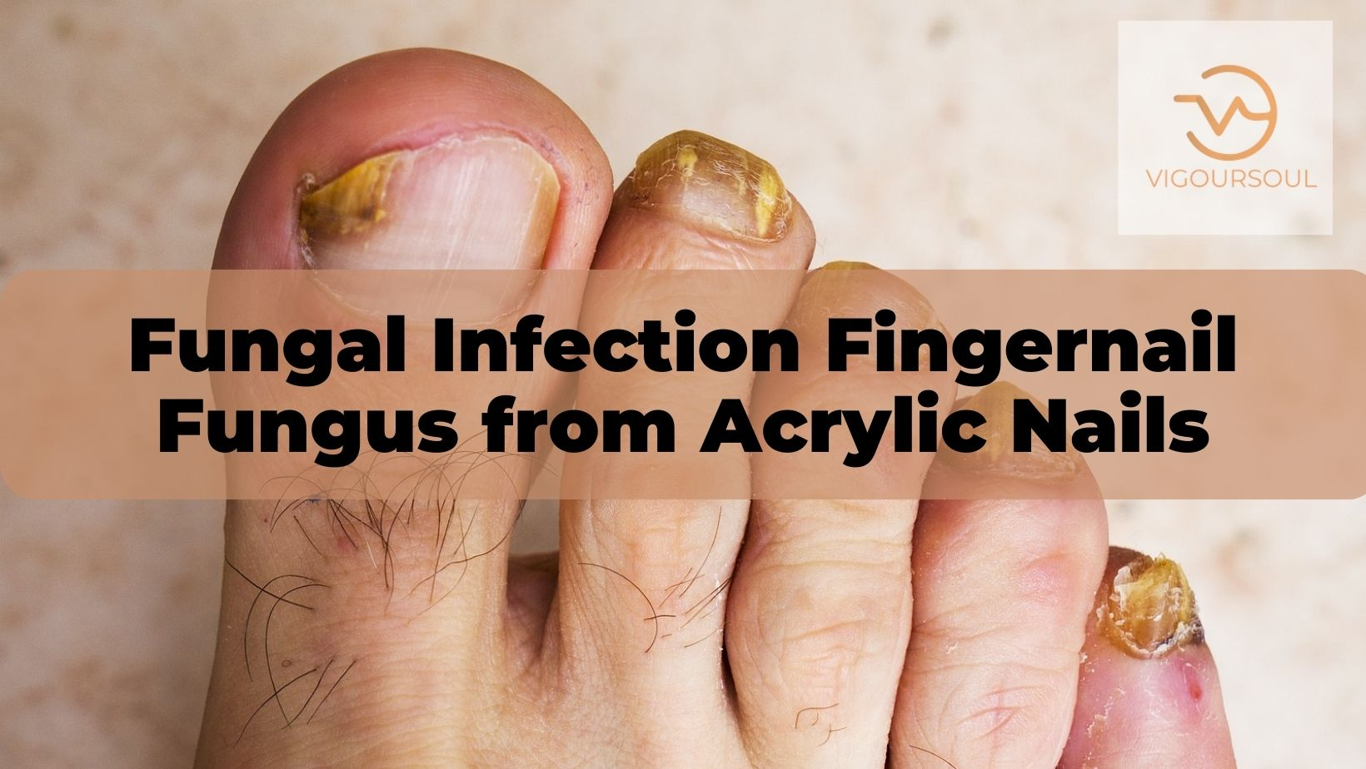

Acrylic nail complications include fungal infections. They are mainly caused by moisture trapped beneath your nails, which promotes fungal development. Most fungal infections are minor and treatable at home. Prescription antifungal drugs frequently cure more severe illnesses.

**Fingernail Bed Injury from** F**ungus from Acrylic Nails:**

* Once a week, buff your nails.
* File your nails in exactly one way.
* Visit a salon for a manicure.
* Once a week, soak your nails in olive oil for a few minutes.
* Consume lots of water and follow a healthy diet.
* Consume biotin supplements.
* To hasten the healing process, use a nail keratin treatment.

**Pseudomonas Bacterial Infection Fingernail Fungus from Acrylic Nails:**

Pseudomonas, or greenies as they are more popularly known, is a frequent bacterial infection found in wet areas, such as under raised artificial nails. When Pseudomonas is found on a nail bed, it is not usually reason for worry.

**Symptoms of Fungus on Fingernails from Acrylic Nails**

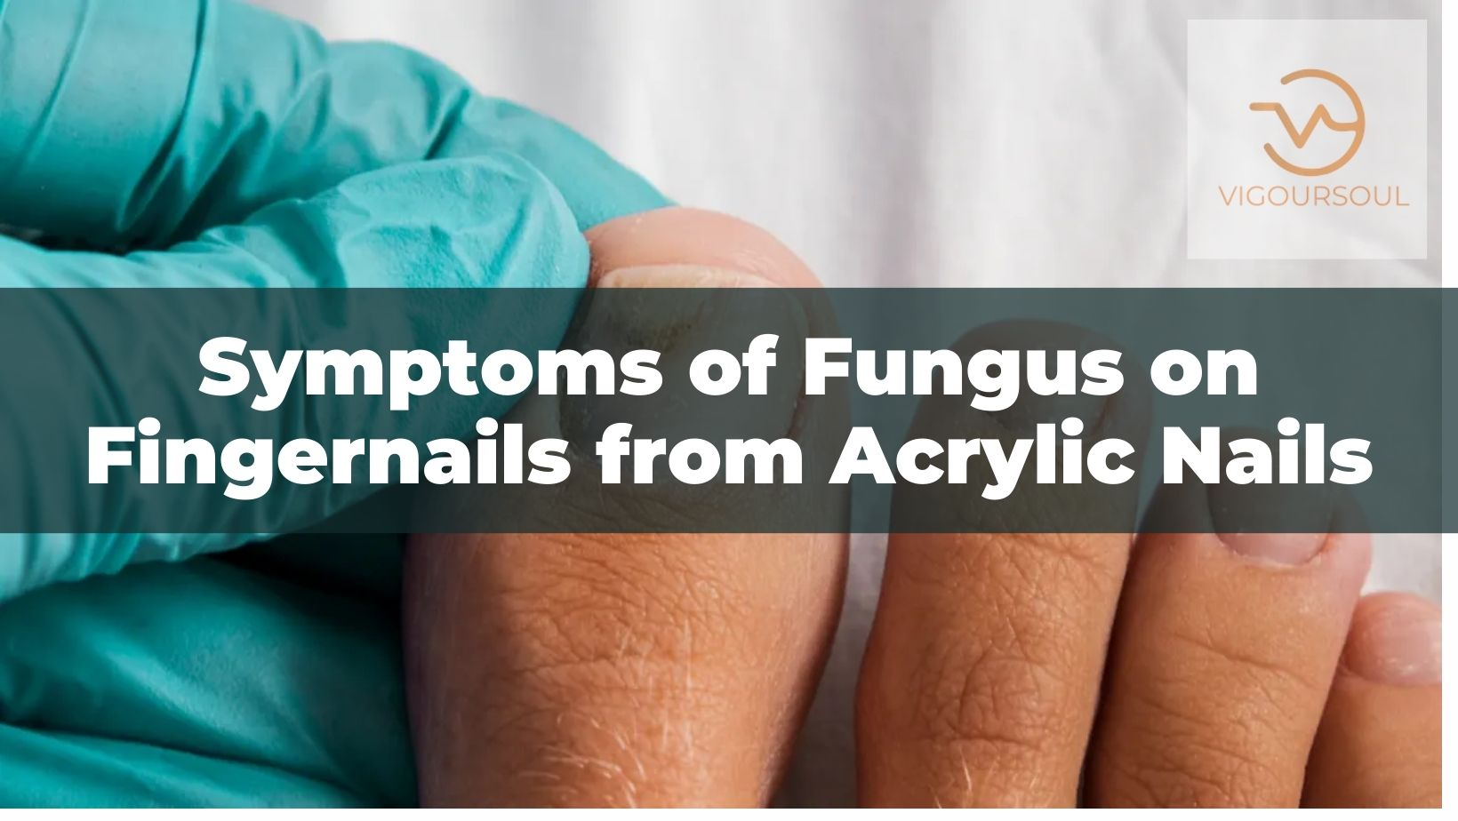

Your fungal infection may not cause any symptoms in the beginning, until it progresses.

As the infection gets worse, you may experience:

* A [brittle or thickened nail](https://www.healthline.com/health/brittle-nails)
* A bad smell coming from the nail
* Pain and soreness, especially when putting pressure on your nail
* A yellow, green, black, or white discoloration
* Itchiness
* Redness
* Swelling

**Causes of Fingernail and Toenail Pain, and How to Treat It?**

* Aside from protecting our fingers and toes, our nails may also provide information about the general health of our bodies.
* They are formed of keratin, which is derived from the cuticle of the nail bed. Health issues might impair nail development, resulting in an irregular nail look. Because nails grow slowly, only a few millimeters each month, it can take up to 6 months for a nail to regenerate and replace unhealthy nails.
* Nail discomfort is frequently unrelated to a major medical problem. Most are caused by temporary issues such as injuries and irritation, which usually resolve with treatment and leave no long-term complications.

**Treating the underlying cause**

Nail discomfort is inconvenient. With therapy, your nails can return to normal sensation and appearance

**Hangnails, Physical Injuries, and Nail Biting:**

The best therapy for nail discomfort caused by most hangnails, physical injuries, and nail biting is to leave your nails alone. Allow hangnails to grow out instead of tearing them out. It is critical to maintain proper nail hygiene by washing and clipping nails on a regular basis.

**Ingrown Nails and Nail Abnormalities:**

Soaking your hands or feet in warm water, wearing appropriate footwear, and taking pain relievers can help alleviate discomfort as they heal. Consult a doctor if your ingrown nails or nail abnormalities do not improve with treatment.

**Nail Infections and Fungal Nail Infections:**

Infections require more care than other illnesses that cause nail discomfort. For bacterial infections, using an over-the-counter anti-bacterial cream to the affected parts of the nail and finger may be sufficient to relieve pain and other symptoms.

Fungal nail infections are commonly treatable with over-the-counter antifungal ointment.

More serious infections need medical treatment, including the use of stronger antibiotics or antifungal drugs. An oral drug may be prescribed by a doctor.

**Takeaway:**

In most situations, nail pain is not significant and may be relieved with over-the-counter medication. However, in rare circumstances, such as infection, seeing a doctor may be essential. Maintaining excellent nail cleanliness and refraining from biting your nails can help prevent nail discomfort and keep your nails healthy.

**FAQS**

**What Causes Nail Fungus to Form Under Acrylic Nails?**

Fungal infections account for more than half of all nail diseases and are especially frequent infections. Among those who use artificial nails. According to one study Trusted Source, 67 of 68 women who suffered nail issues after removing artificial nails had fungal infection.

**How to get Rid of Fingernail Fungus from Acrylic Nails?**

Use a cotton swab to apply oregano oil to your nails twice a day. Mouthwash with Listerine. Listerine has chemicals that are antifungal. Some believe that soaking your finger in original Listerine for 30 minutes every day would help eliminate the illness.

**How to Treat Fingernail Fungus from Acrylic Nails?**

Use a cotton swab to apply oregano oil to your nails twice a day. Mouthwash with Listerine. Listerine has chemicals that are antifungal. Some believe that soaking your finger in original Listerine for 30 minutes every day would help eliminate the illness.

**How does Nail Fungus Happen with Acrylic Nails?**

A fungal nail infection .This can happen when moisture accumulates beneath acrylic nails. It is more frequent in nails that have been kept on for three months or more. This infection can also occur if you rogue the fake nail before cleaning the space.

**Can I Wear Nail Polish While Treating Nail Fungus?**

Nail paint absorbs moisture from the nailed (the tissue below your toenail). Wearing nail paint may aggravate a fungal illness since fungi flourish in damp settings.

**Conclusion:**

Acrylic nail complications include fungal infections. They are mainly caused by moisture trapped beneath your nails, which promotes fungal development. Most fungal infections are minor and treatable at home. Prescription antifungal drugs frequently clean up more severe infections.